实验报告（Lab 2）
姓名：曾泇睷 学号：1820221053
实验：VLAN Configuration and Verification
Lab 2-1 PORT-BASED VLAN CONFIGURATION
Requirements
A network topology is shown in Figure 2-1. Computers of departments A and B in a university are connected to a S5700 switch LSW1. To protect data, it is necessary to allow communication within the department, but isolate the communication between different departments. Please configure two port-based VLANs and assign the Gigabit ports GE /0/0/9 to GE 0/0/12 on the switch to VLAN 10 and ports GE 0/0/13 to GE 0/0/16 to VLAN 30. The computers of Department A are in VLAN 10, and the computers of Department B in VLAN 30.
Step 1: Create the topology, cable a network.
Step 2: Assign the IPv4 address and subnet mask for PCs.
Step 3: Start devices.
Step 4: Configure VLANs on the switch.
Step 5: Verify the configurations.
Answer the following questions:
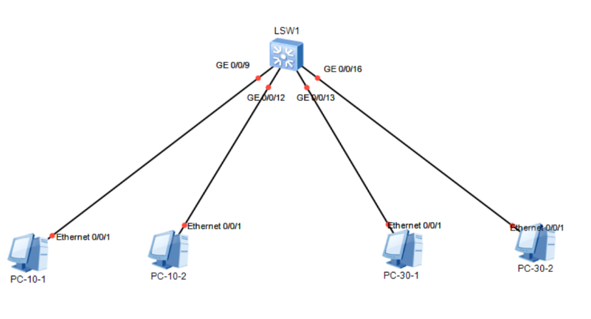
Q2-1.1. Paste the screenshot of the created topology.

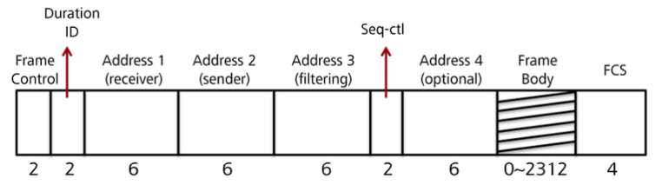
Q2-1.2. Draw IEEE 802.1D tagged frame format.

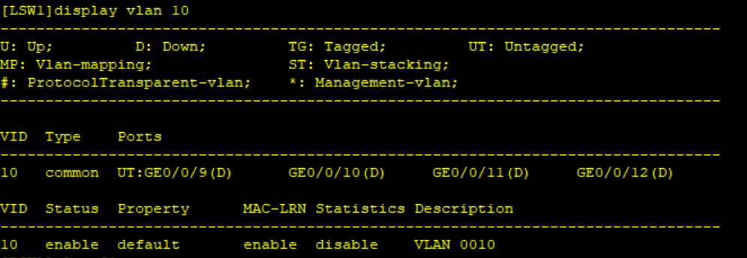
Q2-1.3. Paste the screenshot of VLAN 10 information.

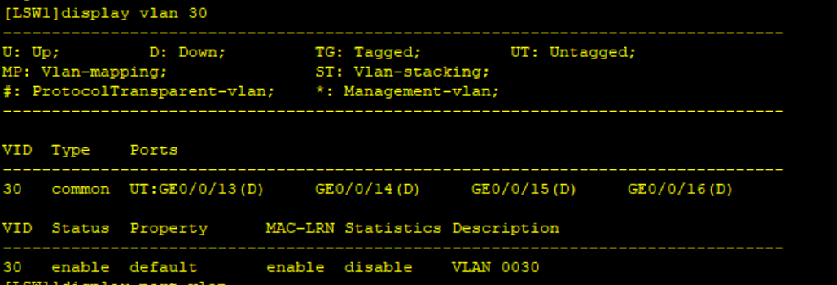
Q2-1.4. Paste the screenshot of VLAN 30 information

Q2-1.5. Suppose you are going to create a new VLAN 40, and add ports 17-20 to this VLAN in batches. Please list the configuration command：
Vlan 40
Port-group pgvlan40
Group-member gigabitethernet 0/0/17 to gigabitethernet 0/0/20
Port link-type access
Port default vlan 40

Q2-1.6. Can PCs in the same VLAN ping each other? Please paste the screenshot of the ping result.
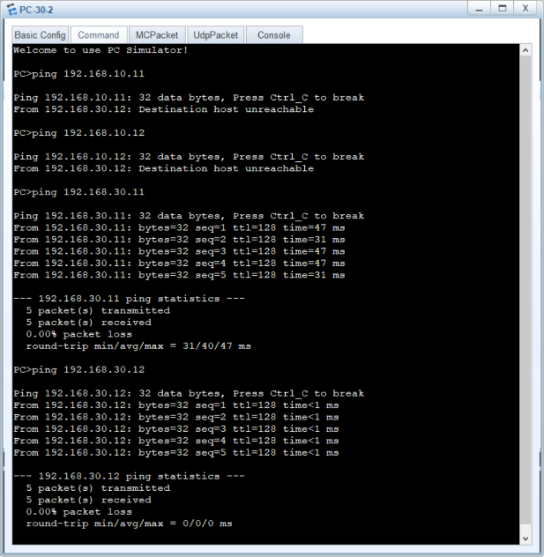
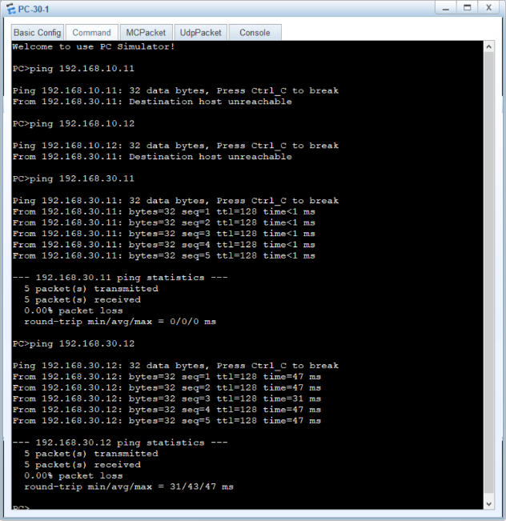
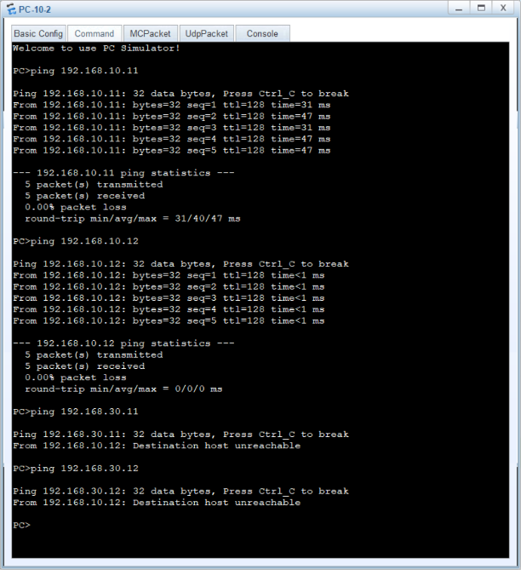
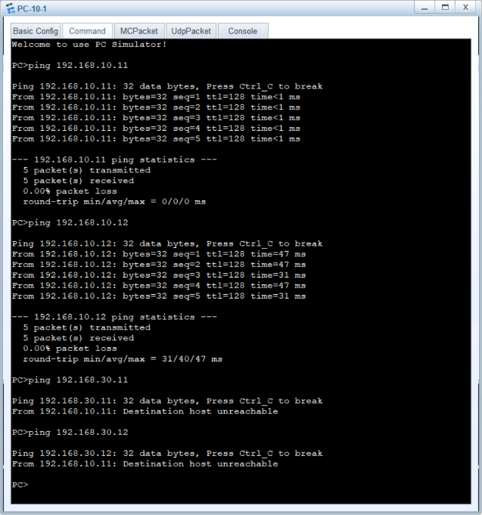
Q2-1.7. Can PCs in different VLANs ping each other? Please paste the screenshot of the ping result. If the ping fails, please explain the reasons.
VLANs separate networks at Layer 2, preventing direct communication between them. Without a router or Layer 3 switch to route traffic between VLANs, devices in different VLANs cannot ping each other. This isolation improves security and reduces unnecessary broadcast traffic.

Lab 2-2 MAC ADDRESS-BASED VLAN CONFIGURATION
Requirements
A network has been implemented in Lab-2-1. The computers of Department A are in VLAN 10, and the computers of Department B in VLAN 30. Now the staff of these two departments often have a meeting together. Each department has a laptop, and each department has a conference room. It is required that no matter which department’s conference room is used, the laptops of each department can access the department’s computers. The network topology is shown in Figure 2-2. Please configure MAC Address-based VLANs.
Step 1: Load and modify the topology.
Step 2: Start devices.
Step 3: Check VLAN Configurations.
Step 4: Assign MAC Addresses to VLANs.
Step 5: Verify the configurations.
Answer the following questions:
Q2-2.1. Paste the screenshot of the created topology.
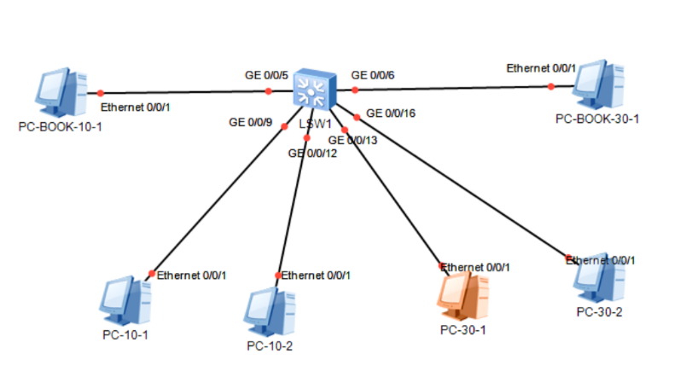
Q2-2.2. Paste the table of MAC addresses of the two laptops you recorded.
Table 2-6 MAC addresses of the two laptops
Laptop | MAC Address
PC-BOOK-10-1 | 54-89-98-A1-67-0E
PC-BOOK-30-1 | 54-89-98-BC-6B-A2

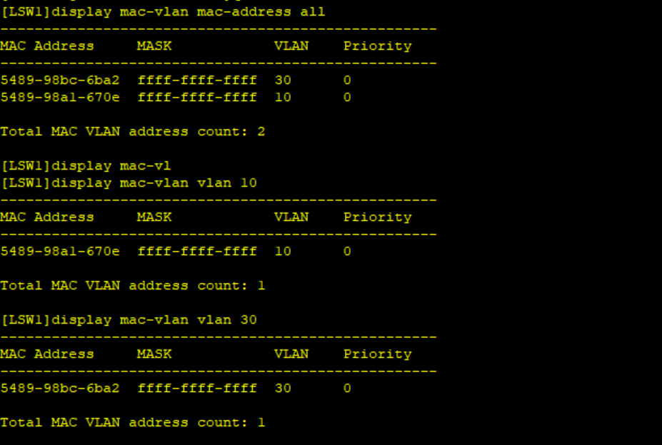
Q2-2.3. Paste the screenshot of the configuration information of all MAC address-based VLANs.

Q2-2.4. When adding members to VLAN 10 and VLAN 30 based on the MAC address, what is the difference between VLAN 10 and VLAN 30 information before and after adding members? Please paste the screenshot of VLAN 10 information before and after adding members.
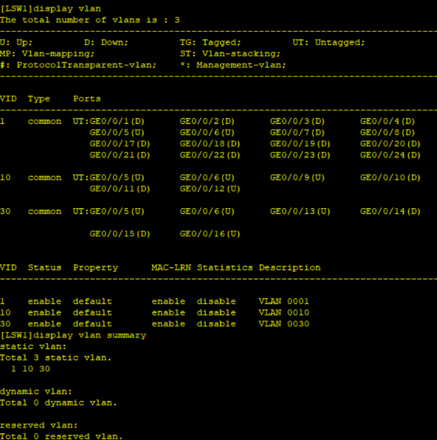
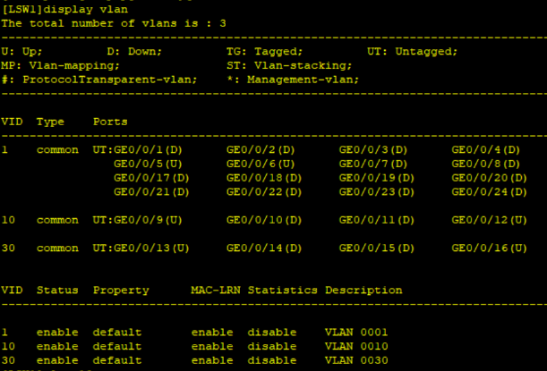
Before: After:

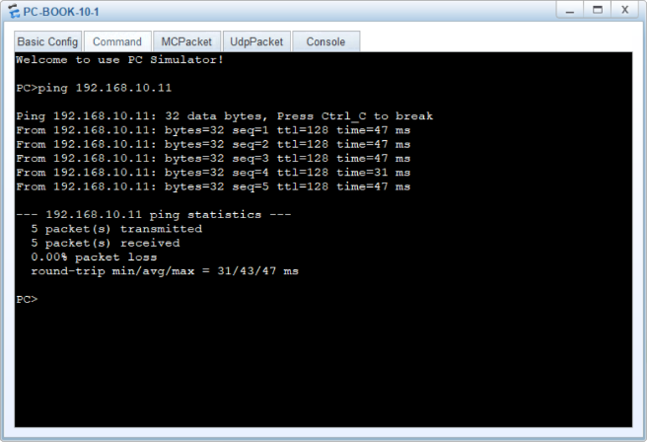
Q2-2.5. Can PC-10-1 ping PC-BOOK10-1 each other? Please paste the screenshot of the ping result.
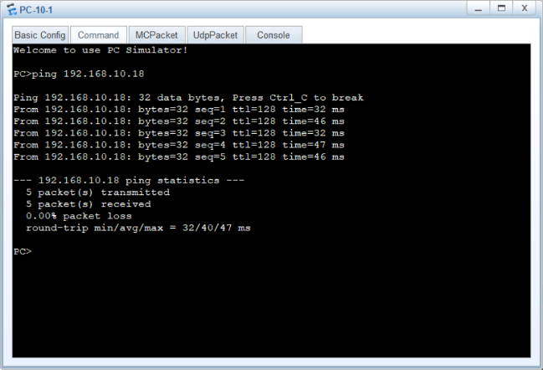
Yes.

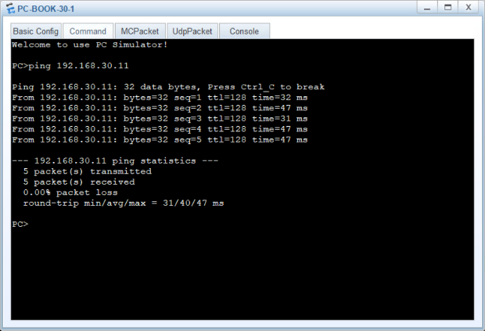
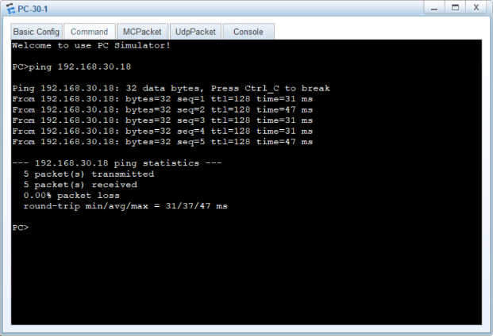
Q2-2.6. Can PC-30-1 ping PC-BOOK30-1 each other? Please paste the screenshot of the ping result.

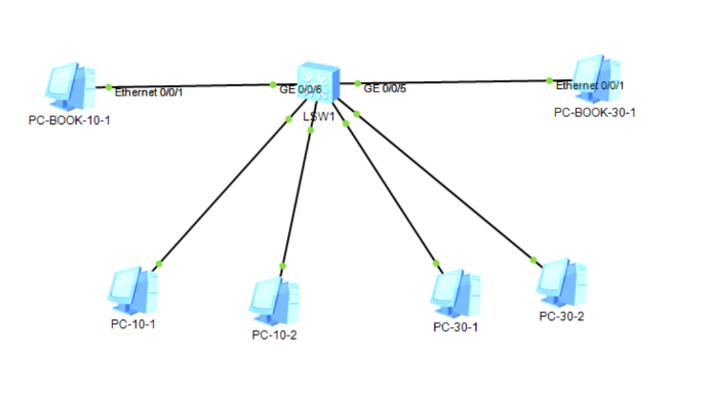
Q2-2.7. Paste the screenshot of the new topology.

Q2-2.8. Can PC-10-1 ping PC-BOOK10-1 each other? Please paste the screenshot of the ping result.
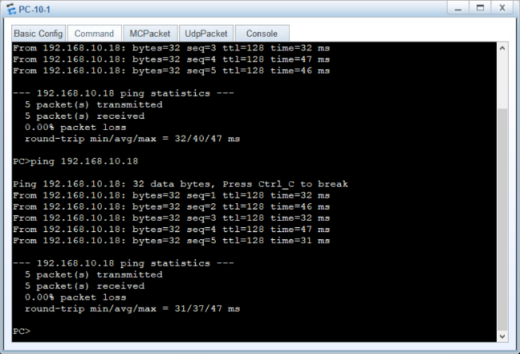
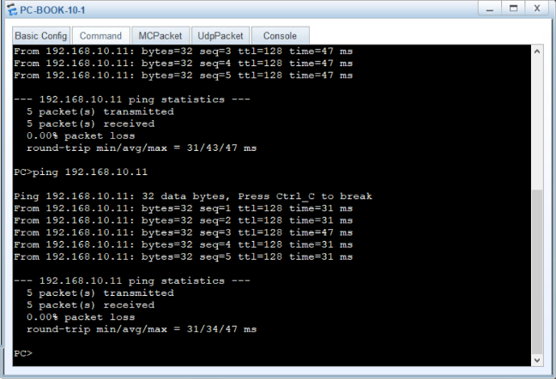
Yes.

Q2-2.9. Can PC-30-1 ping PC-BOOK30-1 each other? Please paste the screenshot of the ping result.
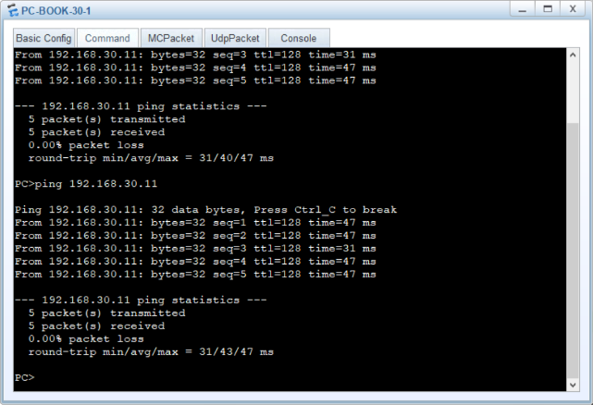
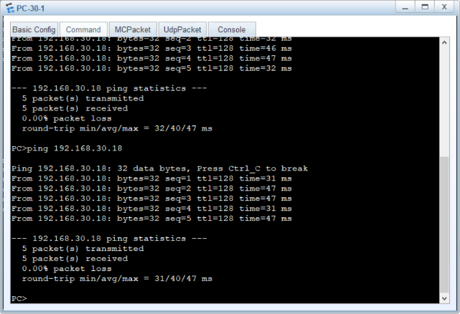
Yes.

Lab 2-3 IP SUBNET-BASED VLAN CONFIGURATION
Requirements
A network has been implemented in Lab-2-2. VLAN 10 and 30 are configured based on port and MAC address. The computers of Department A are in VLAN 10, and the computers of Department B in VLAN 30. Now, each department is equipped with a new computer, and each computer is required to access the VLAN of different departments as needed. The network topology is shown in Figure 2-3. Please configure IP subnet-based VLANs.
Step 1: Load and modify the topology.
Step 2: Start devices.
Step 3: Check VLAN Configurations.
Step 4: Configure IP subnet-based VLANs.
Step 5: Verify the configurations.
Answer the following questions:
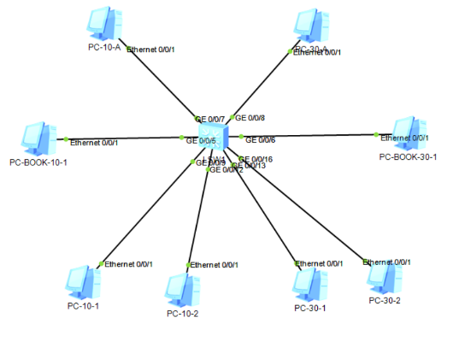
Q2-3.1. Paste the screenshot of the created topology.
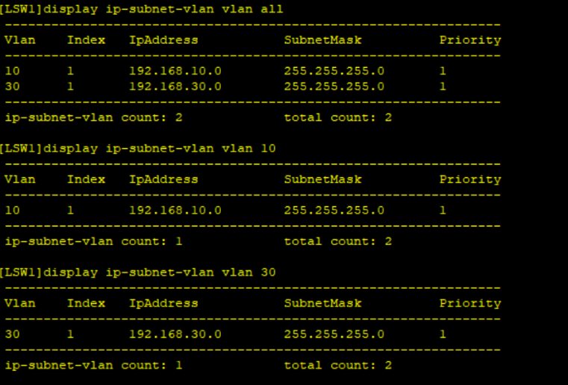
Q2-3.2. Paste the screenshot of the configuration information of all IP subnet-based VLANs.
Q2-3.3. Can PC-10-1, PC-BOOK10-1 and PC-10-A ping each other? Please paste the screenshot of the ping result.
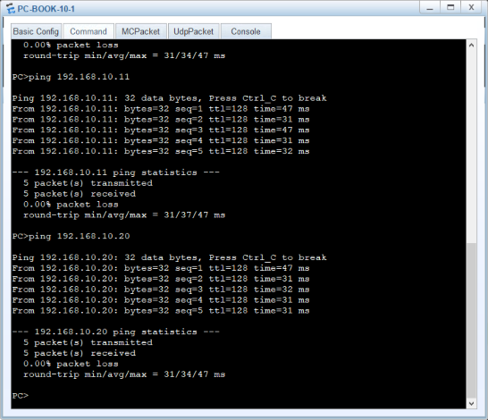
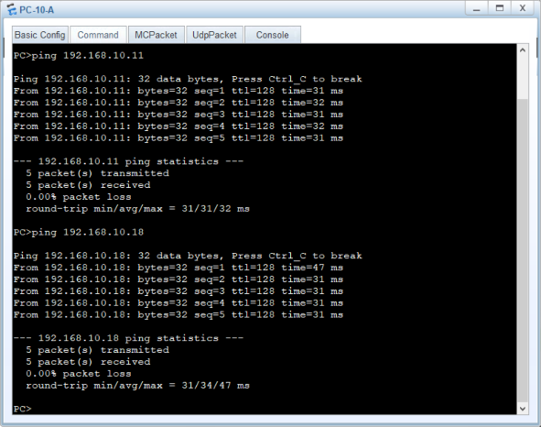
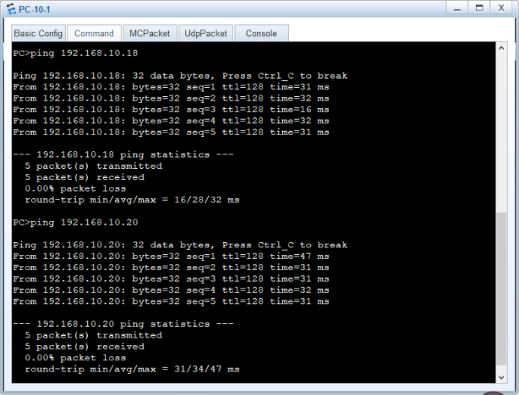
Yes.

Q2-3.4. Can PC-30-1, PC-BOOK30-1 and PC-30-A ping each other? Please paste the screenshot of the ping result.
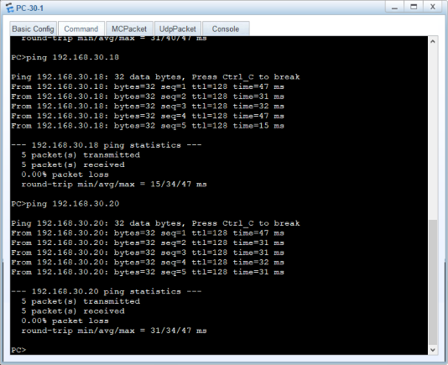
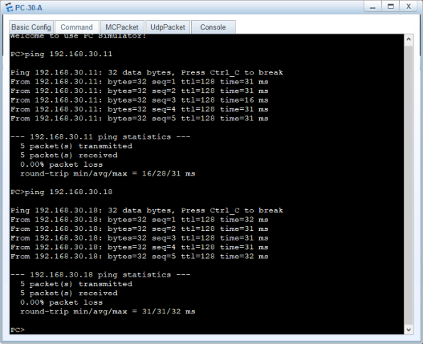
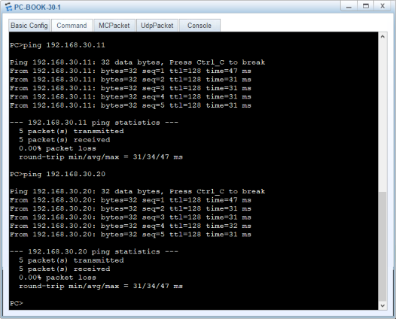
Yes.

Q2-3.5. Can PC-10-1, PC-BOOK10-1 and PC-30-A ping each other? Please paste the screenshot of the ping result.
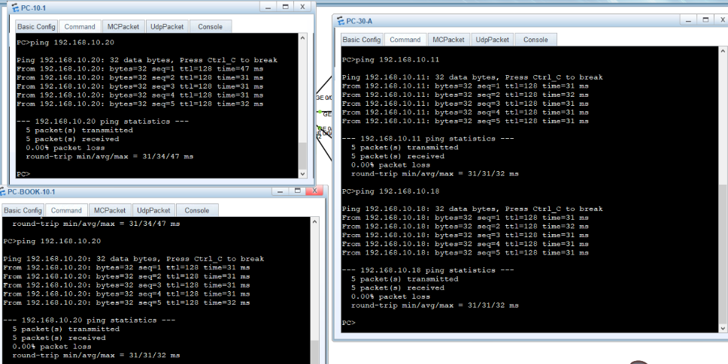
Yes.
Q2-3.6. Can PC-30-1, PC-BOOK30-1 and PC-10-A ping each other? Please paste the screenshot of the ping result.
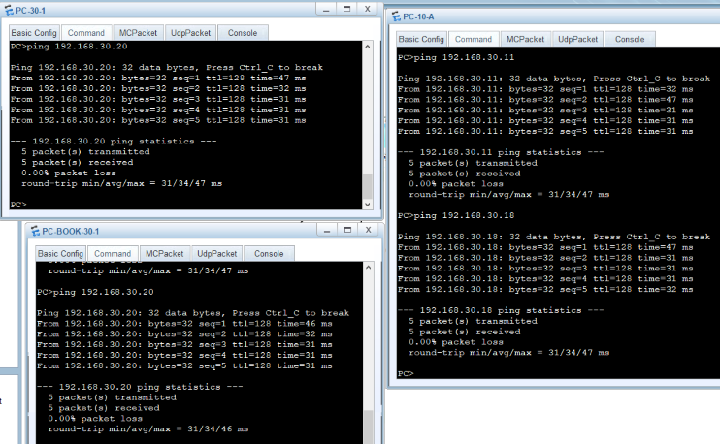
Yes.

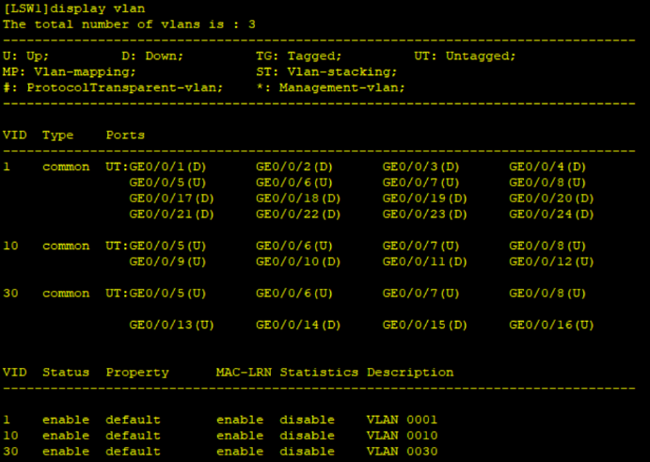
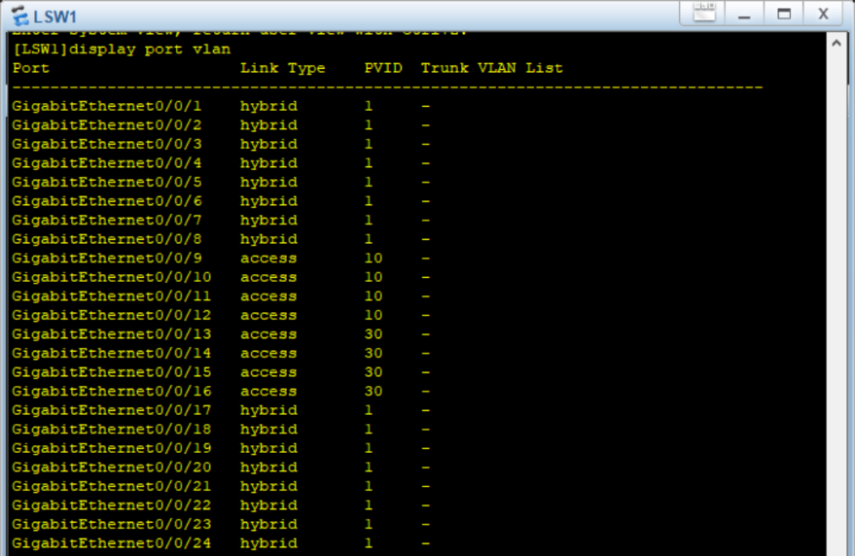
Q2-3.7. Paste information about ports or interfaces that belong to each VLAN.

Lab 2-4 802.1Q TRUNK CONFIGURATION
Requirements
A network has been implemented in Lab-2-1. The computers of Department A are in VLAN 10, and the computers of Department B in VLAN 30. Recently, the staff and computers in these two departments have increased, and there are also more offices. The original switch can no longer connect to more computers, and the system needs to be expanded. The solution is to add a switch and configure a trunk between the switches to achieve VLAN cross-switch span. The network topology is shown in Figure 2-4. Please configure trunk between switches to span VLANs across switches.
Step 1: Load and modify the topology.
Step 2: Start devices.
Step 3: Check VLAN Configurations.
Step 4: Configure a trunk between switches.
Step 5: Verify the configurations and analyze the traffic on the trunk link.
Answer the following questions:
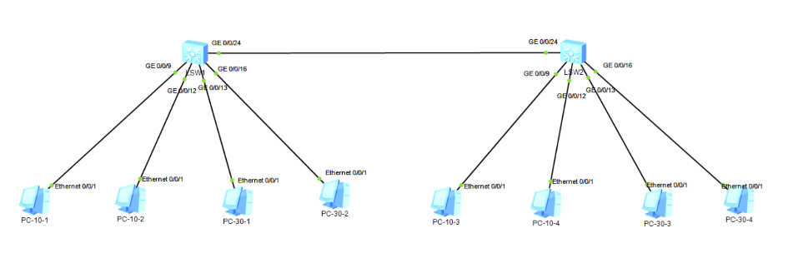
Q2-4.1. Paste the screenshot of the created topology.

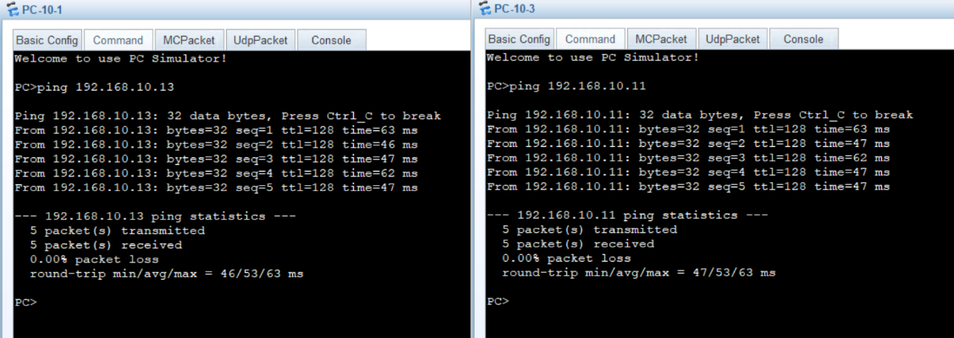
Q2-4.2. Can PC-10-1 and PC-10-3 ping each other? Please paste the screenshot of the ping result.
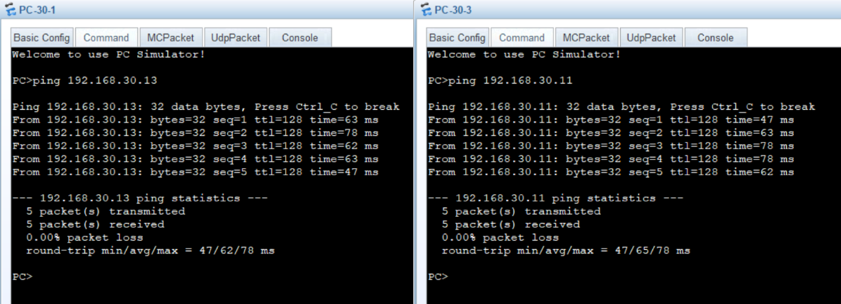
Q2-4.3. Can PC-30-1 and PC-30-3 ping each other? Please paste the screenshot of the ping result.

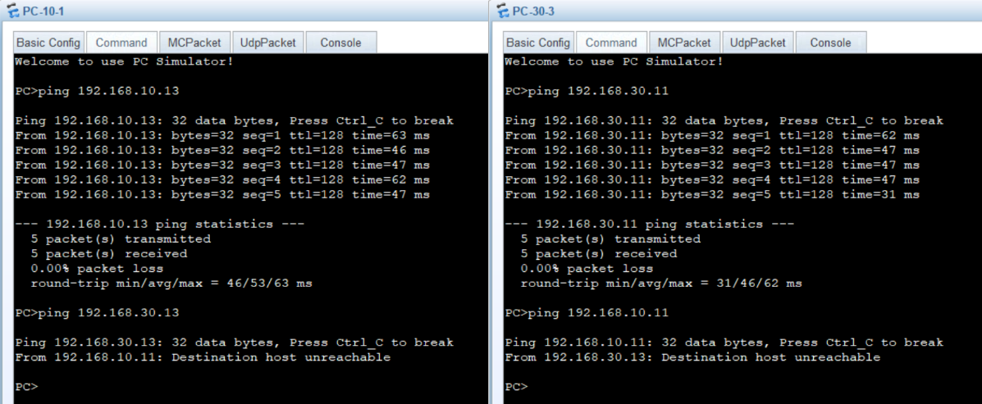
Q2-4.4. Can PC-10-1 and PC-30-3 ping each other? Please paste the screenshot of the ping result.

Q2-4.5. Are the Ethernet frames captured on interface GE 0/0/24 on switch LSW1 tagged or untagged frames? If they are tagged frames, what are the VLAN IDs? Please paste the screenshot of all field information of two captured Ethernet frames with different VLAN IDs.

Q2-4.6. Are the Ethernet frames captured on interface GE 0/0/9 on switch LSW1 tagged or untagged frames? If they are tagged frames, what are the VLAN IDs? Please paste the screenshot of all field information of a captured Ethernet frame.

